Datu sākotnējā ielāde datu bāzē

- Izmantojot komandu INSERT.
- Izmantojot speciālu datu ielādes programmu. Piemēram, SQL*Loader.

Datu ievade tabulā EKAS izmantojot Insert komandu
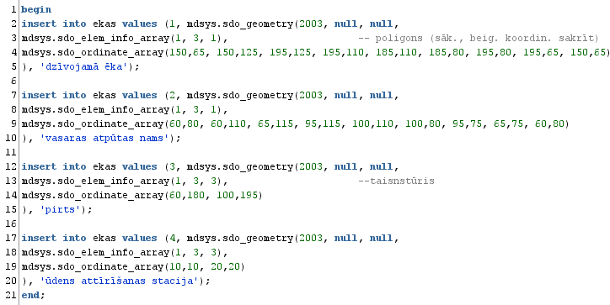

Programma SQL*Loader

Ievadāmo datu faili
(input data files)
Sliktie raksti
(bad files)

Vadības fails
(loader control file)
Programma SQL*Loader
Noraidītie raksti
(discard files)

Datubāze: tabulas, indeksi
Žurnāla fails
(log file)

SQLLDR CONTROL = vad_fails.ctl, DATA = ievad_dati.dat,
LOG = zurn_fails.log, BAD = slikti_raksti.bad,
USERID = system/janis,
ERRORS = 999, Cik maksimāli var būt kļūdas ievadē.
LOAD = 2000, Ievadāmo rakstu maksimālais skaits.
DISCARD = noraid_raksti.dsc,
DISCARDMAX = 5 Cik maksimāli var būt noraidītie raksti.

SQL*Loader datu ievades komandu un datu fails

Faila 02_ekas_stavi.ctl saturs | Faila 02_ekas_stavi.dat saturs
load data  infile '02_ekas_stavi.dat'  into table ekas_stavi  fields terminated by ','  (ekas_id, stava_numurs, telpu_skaits, apkure) | --ekas_id, stava_numurs, telpu_skaits, apkure  1,0,2,0  1,1,6,1  1,2,5,1  2,1,3,1  2,2,4,1  3,1,4,1  4,1,1,0
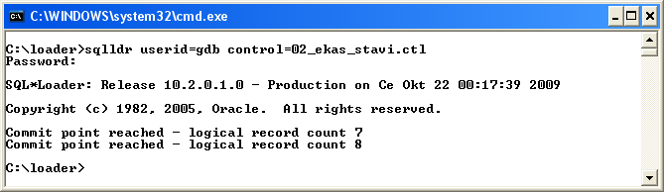

Ģeometrisko datu ievades komandu un datu faili

Faila 03_koki.ctl saturs | Faila 03_koki.dat saturs
load data  infile '03_koki.dat'  into table koki  fields terminated by ','  (koka_id,  geometrija column object (  sdo_gtype constant 2003,  sdo_elem_info varray count (constant 3) (x),  sdo_ordinates varray count (constant 6) (y)  ),  nosaukums ) | 1, 1,3,4, 50,110, 55,115, 50,120,ābele  2, 1,3,4, 150,10, 155,15, 150,20,egle  3, 1,3,4, 185,20, 190,25, 185,30,plūme  4, 1,3,4, 185,35, 190,40, 185,45,ķirsis  5, 1,3,4, 185,50, 190,55, 185,60,ķirsis  6, 1,3,4, 185,130, 190,135, 185,140,plūme  7, 1,3,4, 185,145, 190,150, 185,155,plūme  8, 1,3,4, 185,160, 190,165, 185,170,pīlādzis  9, 1,3,4, 180,175, 185,180, 180,185,ābele  10, 1,3,4, 165,180, 170,185, 165,190,ābele  11, 1,3,4, 50,60, 60,70, 50,80,ozols  12, 1,3,4, 130,10, 140,20, 130,30,ozols  13, 1,3,4, 150,30, 160,40, 150,50,ozols  14, 1,3,4, 120,130, 130,140, 120,150,ozols

--vad_fails.ctl
LOAD DATA
INFILE ‘ievad_dati.dat’
INTO TABLE Studenti
FIELDS TERMINATED BY ',' OPTIONALLY ENCLOSED BY ' " '
(KATEDR_NUM POSITION (1) INTEGER EXTERNAL(1))

CREATE TABLE Studenti(
KATEDR_NUM NUMBER);

ievad_dati.dat

1
2

SQLLDR CONTROL = N:\vad_fails.ctl, DATA = N:\ievad_dati.dat, LOG = N:\zurn_fails.log, USERID = SYSTEM/janis

CREATE OR REPLACE TYPE Tips_students AS OBJECT
(S_UZV VARCHAR2(20), S_VAR VARCHAR2(20));

CREATE OR REPLACE TYPE Tips_studenti AS TABLE OF Tips_students;

CREATE TABLE Studenti(
KATEDR_NUM NUMBER,
STUDENTS Tips_studenti)
NESTED TABLE STUDENTS STORE AS Iekl_tabula;

INSERT INTO Studenti VALUES(1, Tips_studenti(Tips_students(‘Zars’, ‘Liene’), Tips_students(‘Celms’, ‘Zane’)));
INSERT INTO Studenti VALUES(2, Tips_studenti(Tips_students(‘Lapa’, ‘Rasma’), Tips_students(‘Sproga’, ‘Juris’)));

-- Vadības faila piemērs
LOAD DATA
INFILE 'ievad_dati.dat'
BADFILE 'slikti_raksti.bad'
DISCARDFILE 'noraid_raksti.dsc'
APPEND -- Ja nav tukša tabula
INTO TABLE Firmas
(REGISTR_DAT SYSDATE,
F_NUM POSITION(1:2) INTEGER EXTERNAL(2) NULLIF F_NUM =
BLANKS,
F_NOS POSITION(7:14) CHAR TERMINATED BY WHITESPACE,
STAT_KAP POSITION(15:22) DECIMAL(7,2),

TERMINATED BY ‘,’
ENCLOSED BY ‘,

